1

Installing R
Now that we’ve got a handle on what a data scientist is, how to find answers, and then spent some time going over a data science example, it’s time to get you set up to start exploring on your own. And the first step of that is installing R.

What is R? What is CRAN?
First, let’s remind ourselves exactly what R is and why we might want to use it.
R is both a programming language and an environment, focused mainly on statistical analysis and graphics. It will be one of the main tools you use in this and following courses.
R is downloaded from the Comprehensive R Archive Network, or CRAN, and while this might be your first brush with it, we will be returning to CRAN time and time again, when we install packages - so keep an eye out!

Why should you use R?
Outside of this course, you may be asking yourself - why should I use R?
The reasons for using R are myriad, but some big ones are:
1) Its popularity
R is quickly becoming the standard language for statistical analysis. This makes R a great language to learn as the more popular a software is, the quicker new functionality is developed, the more powerful it becomes, and the better the support there is! Additionally, as you can see in the graph below, knowing R is one of the top five languages asked for in data scientist job postings!
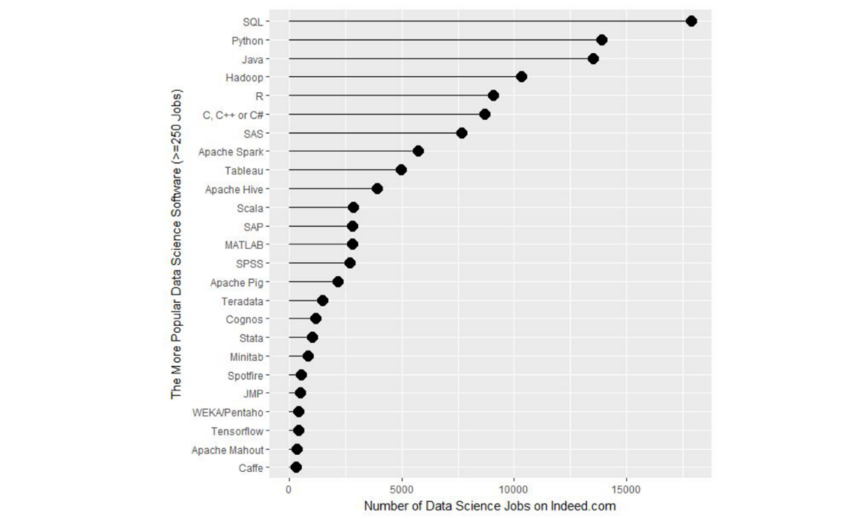

R’s popularity among data scientists from r4stats.com
2) Its cost
FREE!
This one is pretty self-explanatory - every aspect of R is free to use, unlike some other stats packages you may have heard of (eg: SAS, SPSS), so there is no cost barrier to using R!
3) Its extensive functionality
R is a very versatile language - we’ve talked about its use in stats and in graphing, but its use can be expanded to many different functions - from making websites, making maps using GIS data, analysing language… and even making these lectures and videos! For whatever task you have in mind, there is often a package available for download that does exactly that!
4) Its community
And the reason that the functionality of R is so extensive is the community that has been built around R. Individuals have come together to make “packages” that add to the functionality of R - and more are being developed every day!
Particularly for people just getting started out with R, its community is a huge benefit - due to its popularity, there are multiple forums that have pages and pages dedicated to solving R problems. We talked about this in the Getting Help lesson; these forums are great both for finding other people who have had the same problem as you, and posting your own new problems.

Installing R
Now that we’ve spent some time looking at the benefits of R, it is time to install it! We’ll go over installation for both Windows and Mac below, but know that these are general guidelines and small details are likely to change subsequent to the making of this lecture - use this as a scaffold.
For both Windows and Mac machines, we start at the CRAN homepage: https://cran.r-project.org/

Installation - for Windows
If you are on a Windows computer, follow the link Download R for Windows, and follow the directions there - if this is your first time installing R, go to the base distribution and click on the link at the top of the page that should say something like “Download R [version number] for Windows.” This will download an executable file for installation.
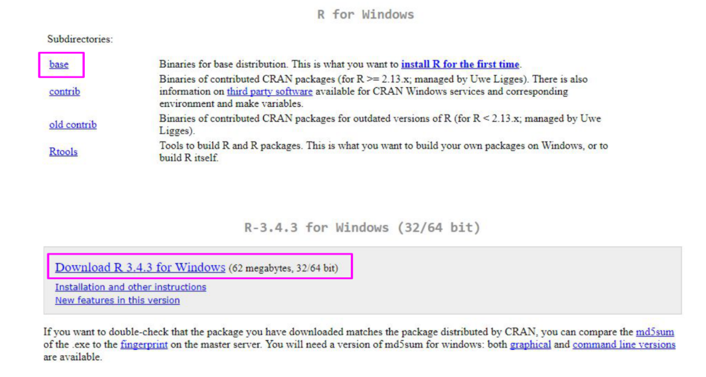

The download page for R on Windows

Open the executable, and if prompted by a security warning, allow it to run. Select the language you prefer during installation and agree to the licensing information. You will next be prompted for a destination location - this will likely be defaulted to Program Files, in a subfolder called R, followed by another directory of the version number. Unless you have any issues with this, the default location is perfect.
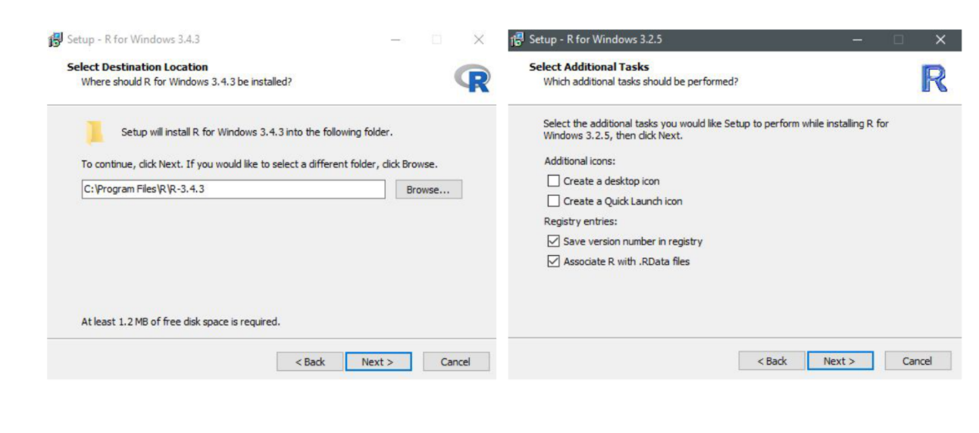

The install wizard for installing R
You will then be prompted to select which components should be installed. Unless you are running short on memory, installing all of the components is desireable. Next you’ll be asked about startup options, and again, the defaults are fine for this. You will then be asked where Setup should place shortcuts - this is completely up to you, you can allow it to add the program to the start menu, or you can click the box at the bottom that says to not create a start menu link. Finally, you will be asked whether you want a desktop or Quick Launch icon - up to you! I do not recommend changing the defaults for the registry entries though.
After this window, the installation should begin. Test that the installation worked by opening R for the first time!
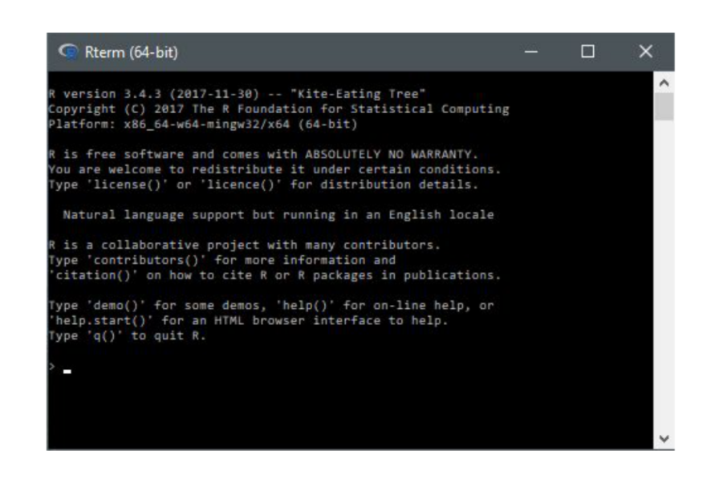

The R terminal running!

Installation - for Macs
If you are on a Mac computer, follow the link Download R for (Mac) OS X. There you can find the various R versions for download. Note: If your Mac is older than OS X 10.6 (“Snow Leopard”), you will need to follow the directions on this page for downloading older versions of R that are compatible with those operating systems.
Click on the link to the most recent version of R, which will download a .pkg file.
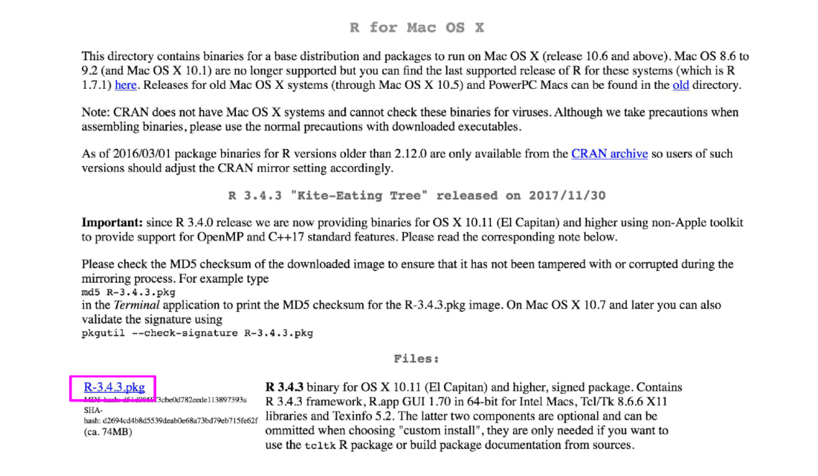

Downloading the .pkg file for Macs
Open the pkg file and follow the prompts as provided by the installer. First, click continue on the welcome page and again on the important information window page. Next you will be presented with the software license agreement, again, continue. Next you may be asked to select a destination for R, either available to all users or to a specific disk - select whichever you feel is best suited to your setup. Finally, you will be at the “Standard Install” page; R selects a default directory and if you are happy with that location, go ahead and click install. At this point, you may be prompted to type in the admin password, do so, and the install will begin!
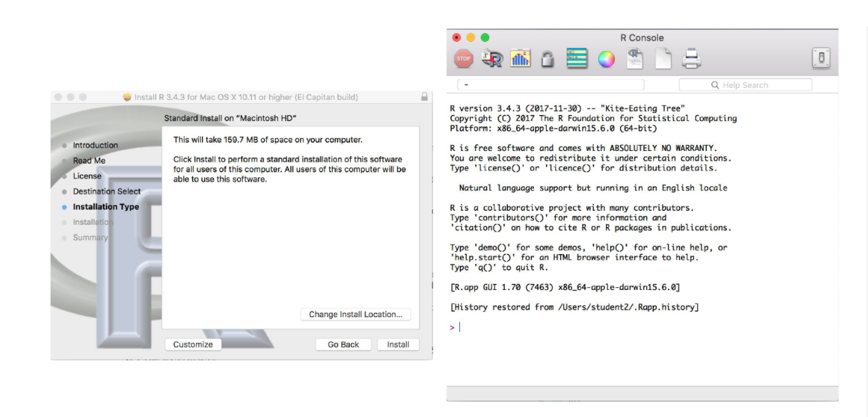

Installation of R on a Mac
Once the installation is finished, go to your Applications and find R. Test that the installation worked by opening R for the first time!

Summary
In this lesson we first looked at what R is and why we might want to use it. We then focused on the installation process for R on both Windows and Mac computers. Before moving on to the next lecture, be sure that you have R installed properly.

2

Installing RStudio
We’ve installed R and can open the R interface to input code, but there are other ways to interface with R - and one of those ways is using RStudio. In this lesson, we’ll get RStudio installed on your computer.

What is RStudio?
RStudio is a graphical user interface for R, that allows you to write, edit and store code, generate, view and store plots, manage files, objects and dataframes, and integrate with version control systems – to name a few of its functions. We will be exploring exactly what RStudio can do for you in future lessons, but for anybody just starting out with R coding, the visual nature of this program as an interface for R is a huge benefit.
Installing RStudio
Thankfully, installation of RStudio is fairly straightforward. First, you go to the RStudio download page. We want to download the RStudio Desktop version of the software, so click on the appropriate “Download” , under that heading and you will see a list of “Installers for supported platforms”.

The RStudio download page. Select RStudio Desktop

The various versions of RStudio available for different operating systems
At this point the installation process diverges for Macs and Windows, so follow the instructions for the appropriate OS.

Installing RStudio - Windows
For Windows, select the RStudio installer for the various Windows editions (Vista, 7, 8, 10). This will initiate the download process. When the download is complete, open this executable file to access the installation wizard. You may be presented with a security warning at this time - allow it to make changes to your computer.
Following this, the installation wizard will open. Following the defaults on each of the windows of the wizard is appropriate for installation. In brief, on the welcome screen, click next. If you want RStudio installed elsewhere, “Browse” through your file system. Otherwise, it will likely default to the “Program Files” folder - this is appropriate. Click next. On this final page, allow RStudio to create a Start menu shortcut. Click Install. RStudio is now being installed. Wait for this process to finish; RStudio is now installed on your computer. Click Finish.
Check that RStudio is working appropriately by opening it from your Start menu.

The installation wizard for RStudio installation

Completing installation of RStudio

RStudio is running!

Installing RStudio - Macs
For Macs, select the Macs OS X RStudio installer (Mac OS X 10.6+ (64-bit)). This will initiate the download process. When the download is complete, click on the downloaded file and it will begin to install. When this is finished, the applications window will open. Drag the RStudio icon into the Applications directory. Test the installation by opening your applications folder and opening the RStudio software.

Download the Mac appropiate version of RStudio

Drag the RStudio file into your Applications folder to complete installation for RStudio

RStudio is running!

Summary
In this lesson we installed RStudio, both for Macs and for Windows computers. Before moving on to the next lecture, click through the available menus and explore the software a bit. We will have an entire lesson dedicated to exploring RStudio, but having some familiarity beforehand will be helpful!

3

RStudio Tour
Now that we have RStudio installed, we should familiarize ourselves with the various components and functionality of it! RStudio provides a cheatsheet of the RStudio environment - warning: this link initiates a download of a PDF from the RStudio GitHub.

The various quadrants
Rstudio can be roughly divided into four quadrants, each with specific and varied functions, plus a main menu bar. When you first open RStudio, you should see a window that looks roughly like this:
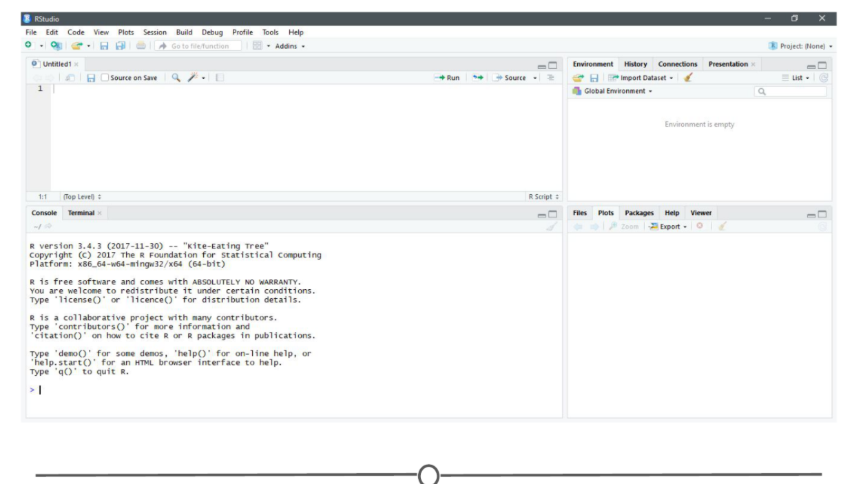
RStudio’s main interface
You may be missing the upper left quadrant and instead have the left side of the screen with just one region, “Console” - if this is the case, go to File > New File > R Script and now it should more closely resemble the image. You can change the sizes of each of the various quadrants by hovering your mouse over the spaces between quadrants and click-dragging the divider to resize the sections.
We will go through each of the regions and describe some of their main functions. It would be impossible to cover everything that RStudio can do, so we urge you to explore RStudio on your own too!
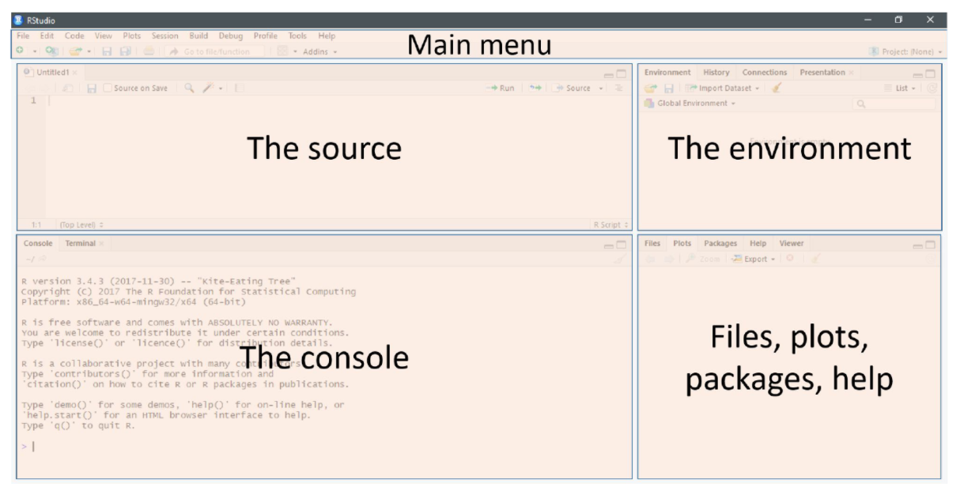
The four main quadrants of RStudio, plus the main menu bar

The menu bar
The menu bar runs across the top of your screen and should have two rows. The first row should be a fairly standard menu, starting with “File” and “Edit.” Below that, there is a row of icons that are shortcuts for functions that you’ll frequently use.
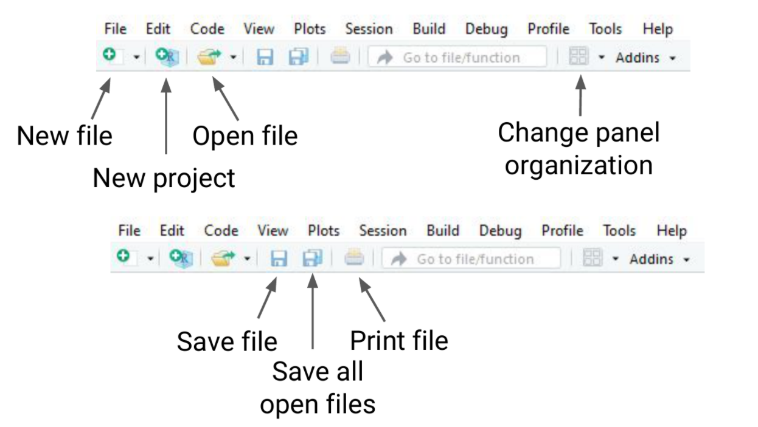
The commonly used options of the main menu bar
To start, let’s explore the main sections of the menu bar that you will use. The first being the File menu. Here we can open new or saved files, open new or saved projects (we’ll have an entire lesson in the future about R Projects, so stay tuned!), save our current document or close RStudio. If you mouse over “New File”, a new menu will appear that suggests the various file formats available to you. R Script and R Markdown files are the most common file types for use, but you can also generate R notebooks, web apps, websites, or slide presentations. If you click on any one of these, a new tab in the “Source” quadrant will open. We’ll spend more time in a future lesson on R Markdown files and their use.
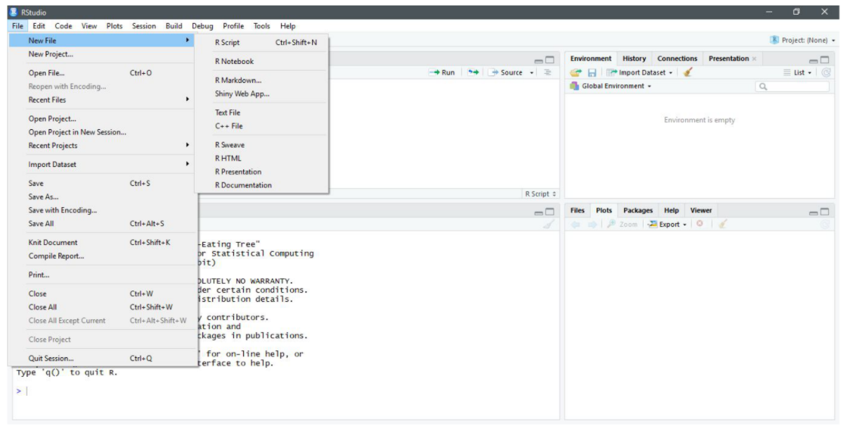

The File menu
The Session menu has some R specific functions, in which you can restart, interrupt or terminate R - these can be helpful if R isn’t behaving or is stuck and you want to stop what it is doing and start from scratch.
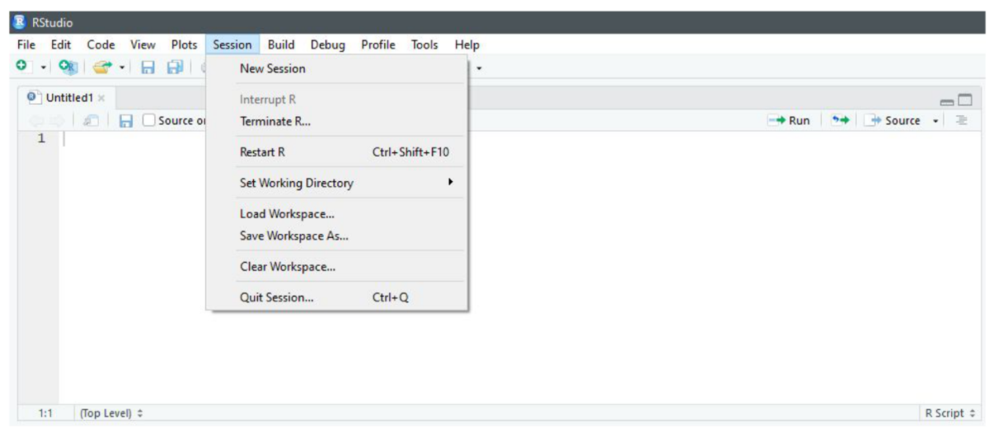
The Session menu
The Tools menu is a treasure trove of functions for you to explore. For now, you should know that this is where you can go to install new packages (see next lecture), set up your version control software (see future lesson: Linking GitHub and RStudio), and set your options and preferences for how RStudio looks and functions. For now, we will leave this alone, but be sure to explore these menus on your own once you have a bit more experience with RStudio and see what you can change to best suit your preferences!

The Tools menu

The console
This region should look familiar to you - when you opened R, you were presented with the console. This is where you type and execute commands, and where the output of said command is displayed.
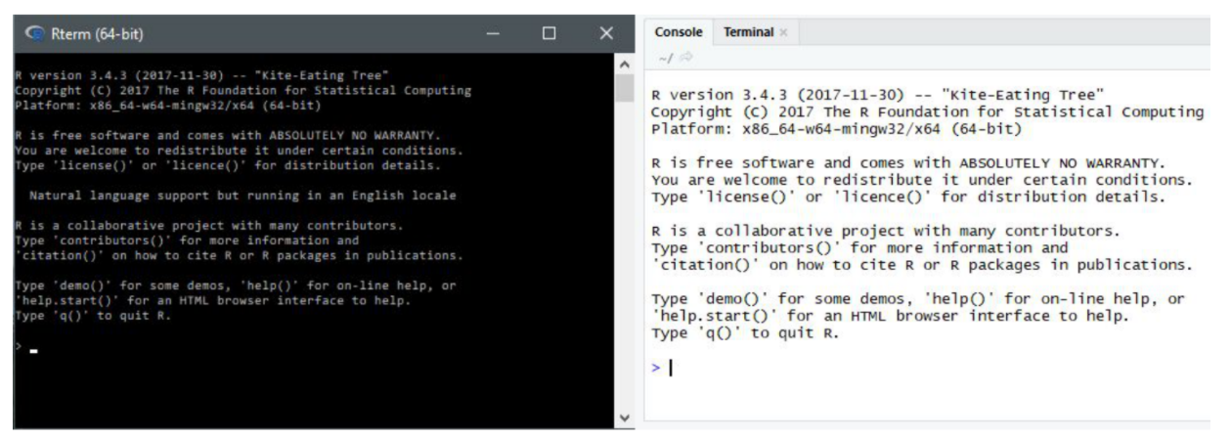
The console
To execute your first command, try typing 1 + 1 then enter at the > prompt. You should see the output [1] 2 below your command.
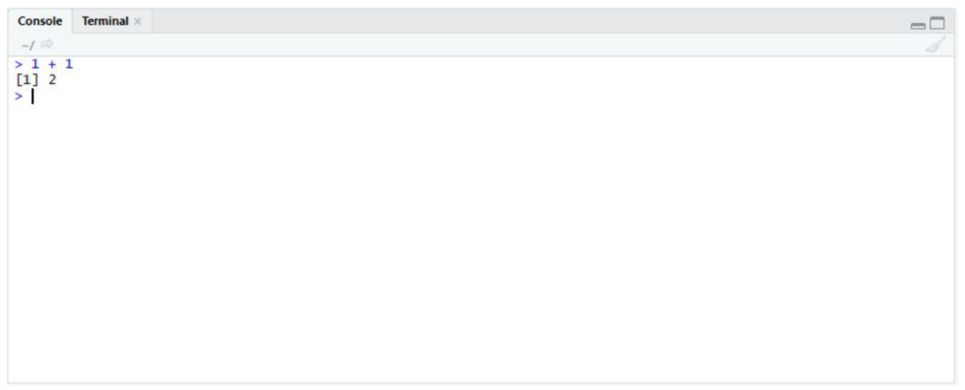
Typing into the console and getting an output
Now copy and paste the following into your console and hit enter.
example <- matrix(c(1, 2, 3, 4, 5, 6, 7, 8), nrow = 4, ncol = 2)
This creates a matrix with four rows and two columns, with the numbers 1 through 8.

The environment/history
To view this matrix, first look to the Environment quadrant, where you should see the following:
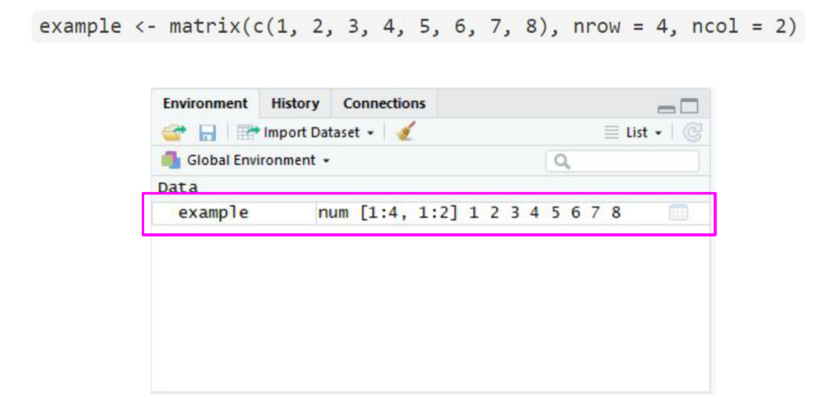

The environment quadrant
Click anywhere on the “example” line, and a new tab on the Source quadrant should appear, showing the matrix you created. Any dataframe or matrix that you create in R can be viewed this way in RStudio.
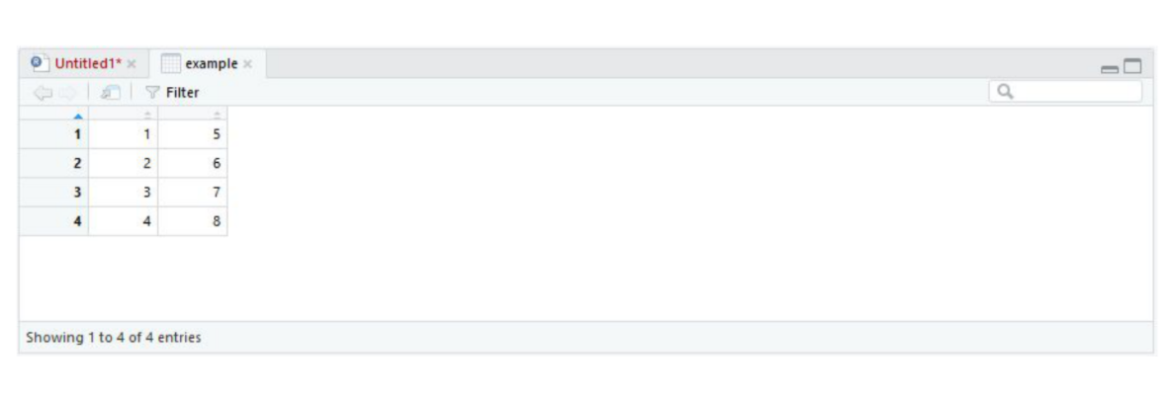
Your newly made matrix, opened in a new tab of the source panel
RStudio also tells you some information about the object in the environment, like whether it is a list or a dataframe or if it contains numbers, integers or characters. This is very helpful information to have as some functions only work with certain classes of data. And knowing what kind of data you have is the first step to that.
The quadrant has two other tabs running across the top of it. We’ll just look at the History tab now. Your history tab should look something like this:
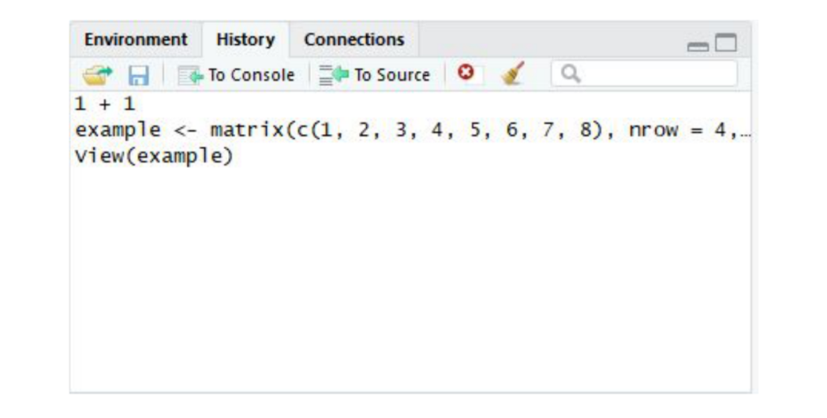
The history tab
Here you will see the commands that we have run in this session of R. If you click on any one of them, you can click “To Console” or “To Source” and this will either rerun the command in the console, or will move the command to the source, respectively. Do so now for your example matrix and send it to Source.
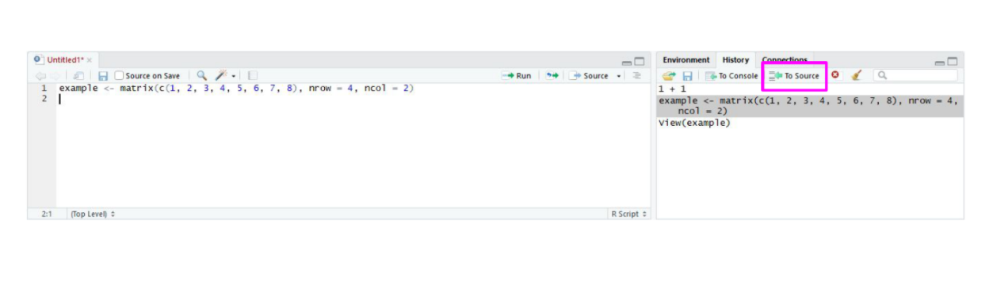
The history tab

The source/The script editor panel
The Source panel is where you will be spending most of your time in RStudio. This is where you store the R commands that you want to save for later, either as a record of what you did or as a way to rerun code. We’ll spend a lot of time in this quadrant when we discuss R Markdown, but for now, click the save icon along the top of this quadrant and save the script as my_first_R_script.R Now you will always have a record of creating this matrix.
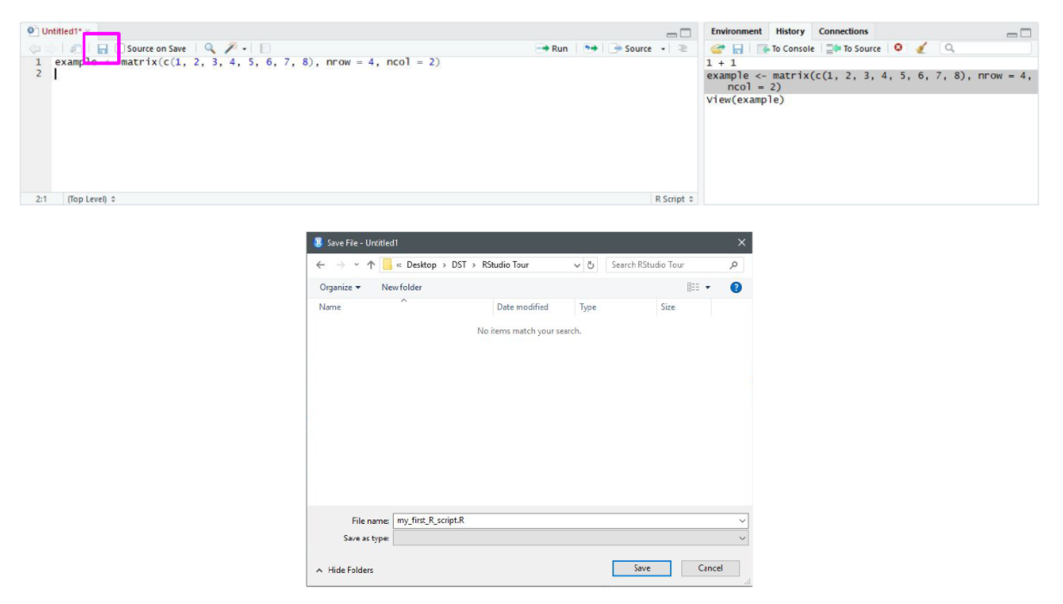
Your first R script!

Files/help/plots/packages panel
The final region we’ll look at occupies the bottom right of the RStudio window. In this quadrant, five tabs run across the top: Files, Plots, Packages, Help, and Viewer.
In Files, you can see all of the files in your current working directory. If this isn’t where you want to save or retrieve files from, you can also change the current working directory in this tab using the ellipsis at the far right, finding the desired folder, and then under the “More” cogwheel, setting this new folder as the working directory.
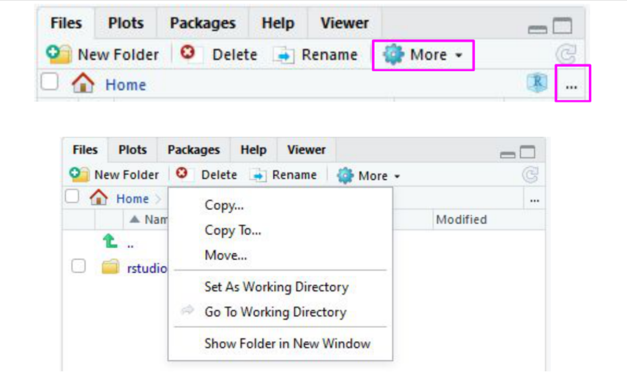
The files tab
In the Plots tab, if you generate a plot with your code, it will appear here. You can use the arrows to navigate to previously generated plots. The Zoom function will open the plot in a new window, that is much larger than the quadrant. Export is how you save the plot. You can either save it as an image or as a PDF. The broom icon clears all plots from memory.
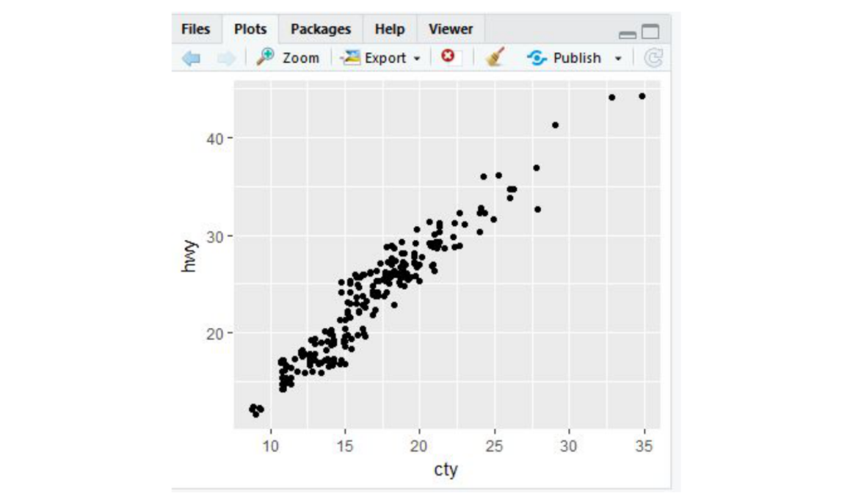
The plots tab
The Packages tab will be explored more in depth in the next lesson on R packages. Here you can see all the packages you have installed, load and unload these packages, and update them.
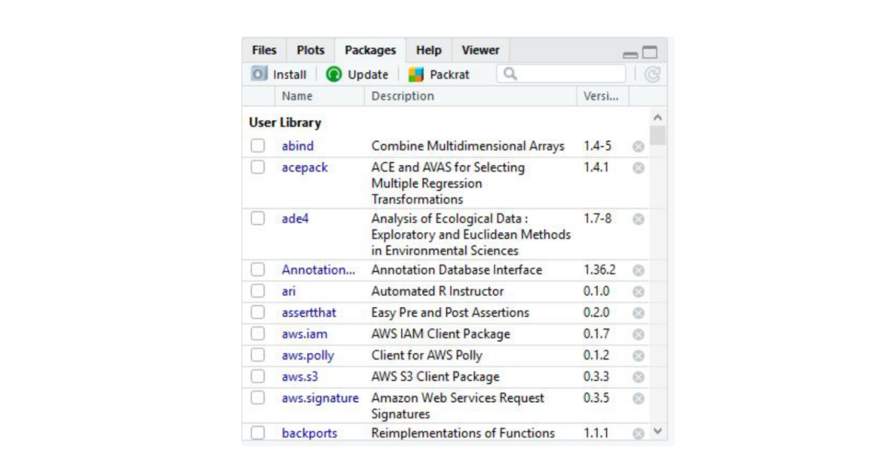
The packages tab
The Help tab is where you find the documentation for your R packages and various functions. In the upper right of this panel there is a search function for when you have a specific function or package in question.
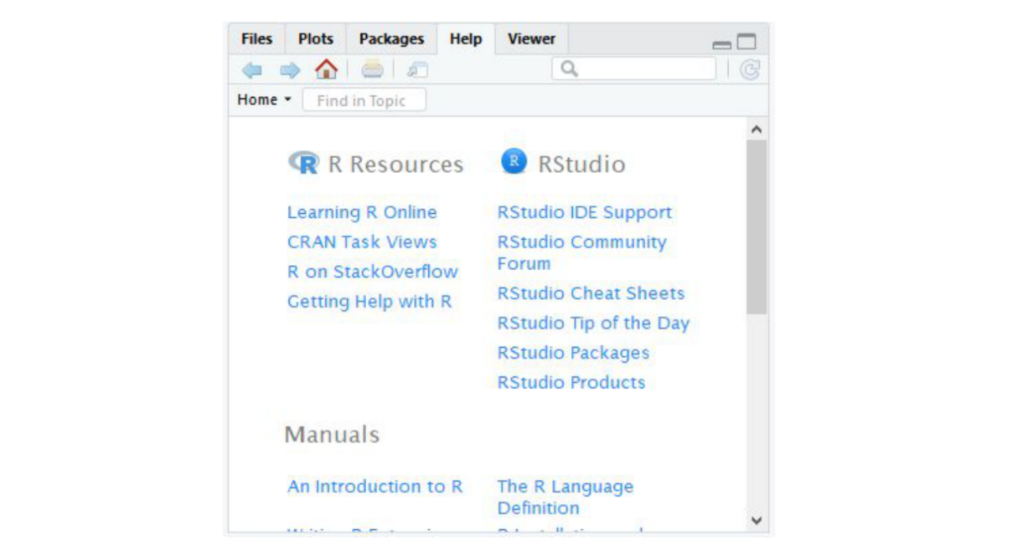
The help tab

Summary
In this lesson we took a tour of the RStudio software. We became familiar with the main menu and its various menus. We looked at the Console, where R code is input and run. We then moved on to the Environment panel that lists all of the objects that have been created within an R session and allows you to view these objects in a new tab in Source. In this same quadrant, there is a History tab, that keeps a record of all commands that have been run. It also presents the option to either rerun the command in the Console, or send the command to Source, to be saved. Source is where you save your R commands. And the bottom right quadrant contains a listing of all the files in your working directory, displays generated plots, lists your installed packages, and supplies help files for when you need some assistance! Take some time to explore RStudio o

